This information is very important when considering our temporary workers for future assignments.
Please complete, sign, and fax this form to the WV ARF office at (304) 766-4607.
THANK YOU

1 = Meets Expectations 3 = Rarely Meets Expectations
2 = Meets Expectations Sometimes 4 = Has Never Met Expectations

EXPECTATIONS
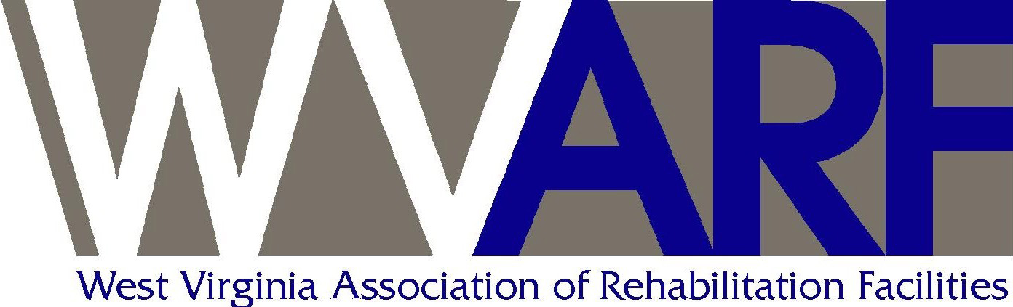  PO Box 745  Institute, WV 25112  Phone: (304) 766-4894 Fax: (304) 766-4607  www.wvarf.org | TEMPORARY EMPLOYEE  PERFORMANCE EVALUATION  FORM
Employee Name: | Date:
State Agency: | Period of Review:
Supervisor/Reviewer: | Title:

1 2 3 4

Dependability
Attendance
Notifies Agency when late or absent
Completes assignments promptly and correctly
Quality of Work
Quantity of Work
Knowledge of work performed
Follows agency policies and procedures
Working Relationships with supervisor, co-workers, visitors

Additional Comments:
Signature: | Title:

