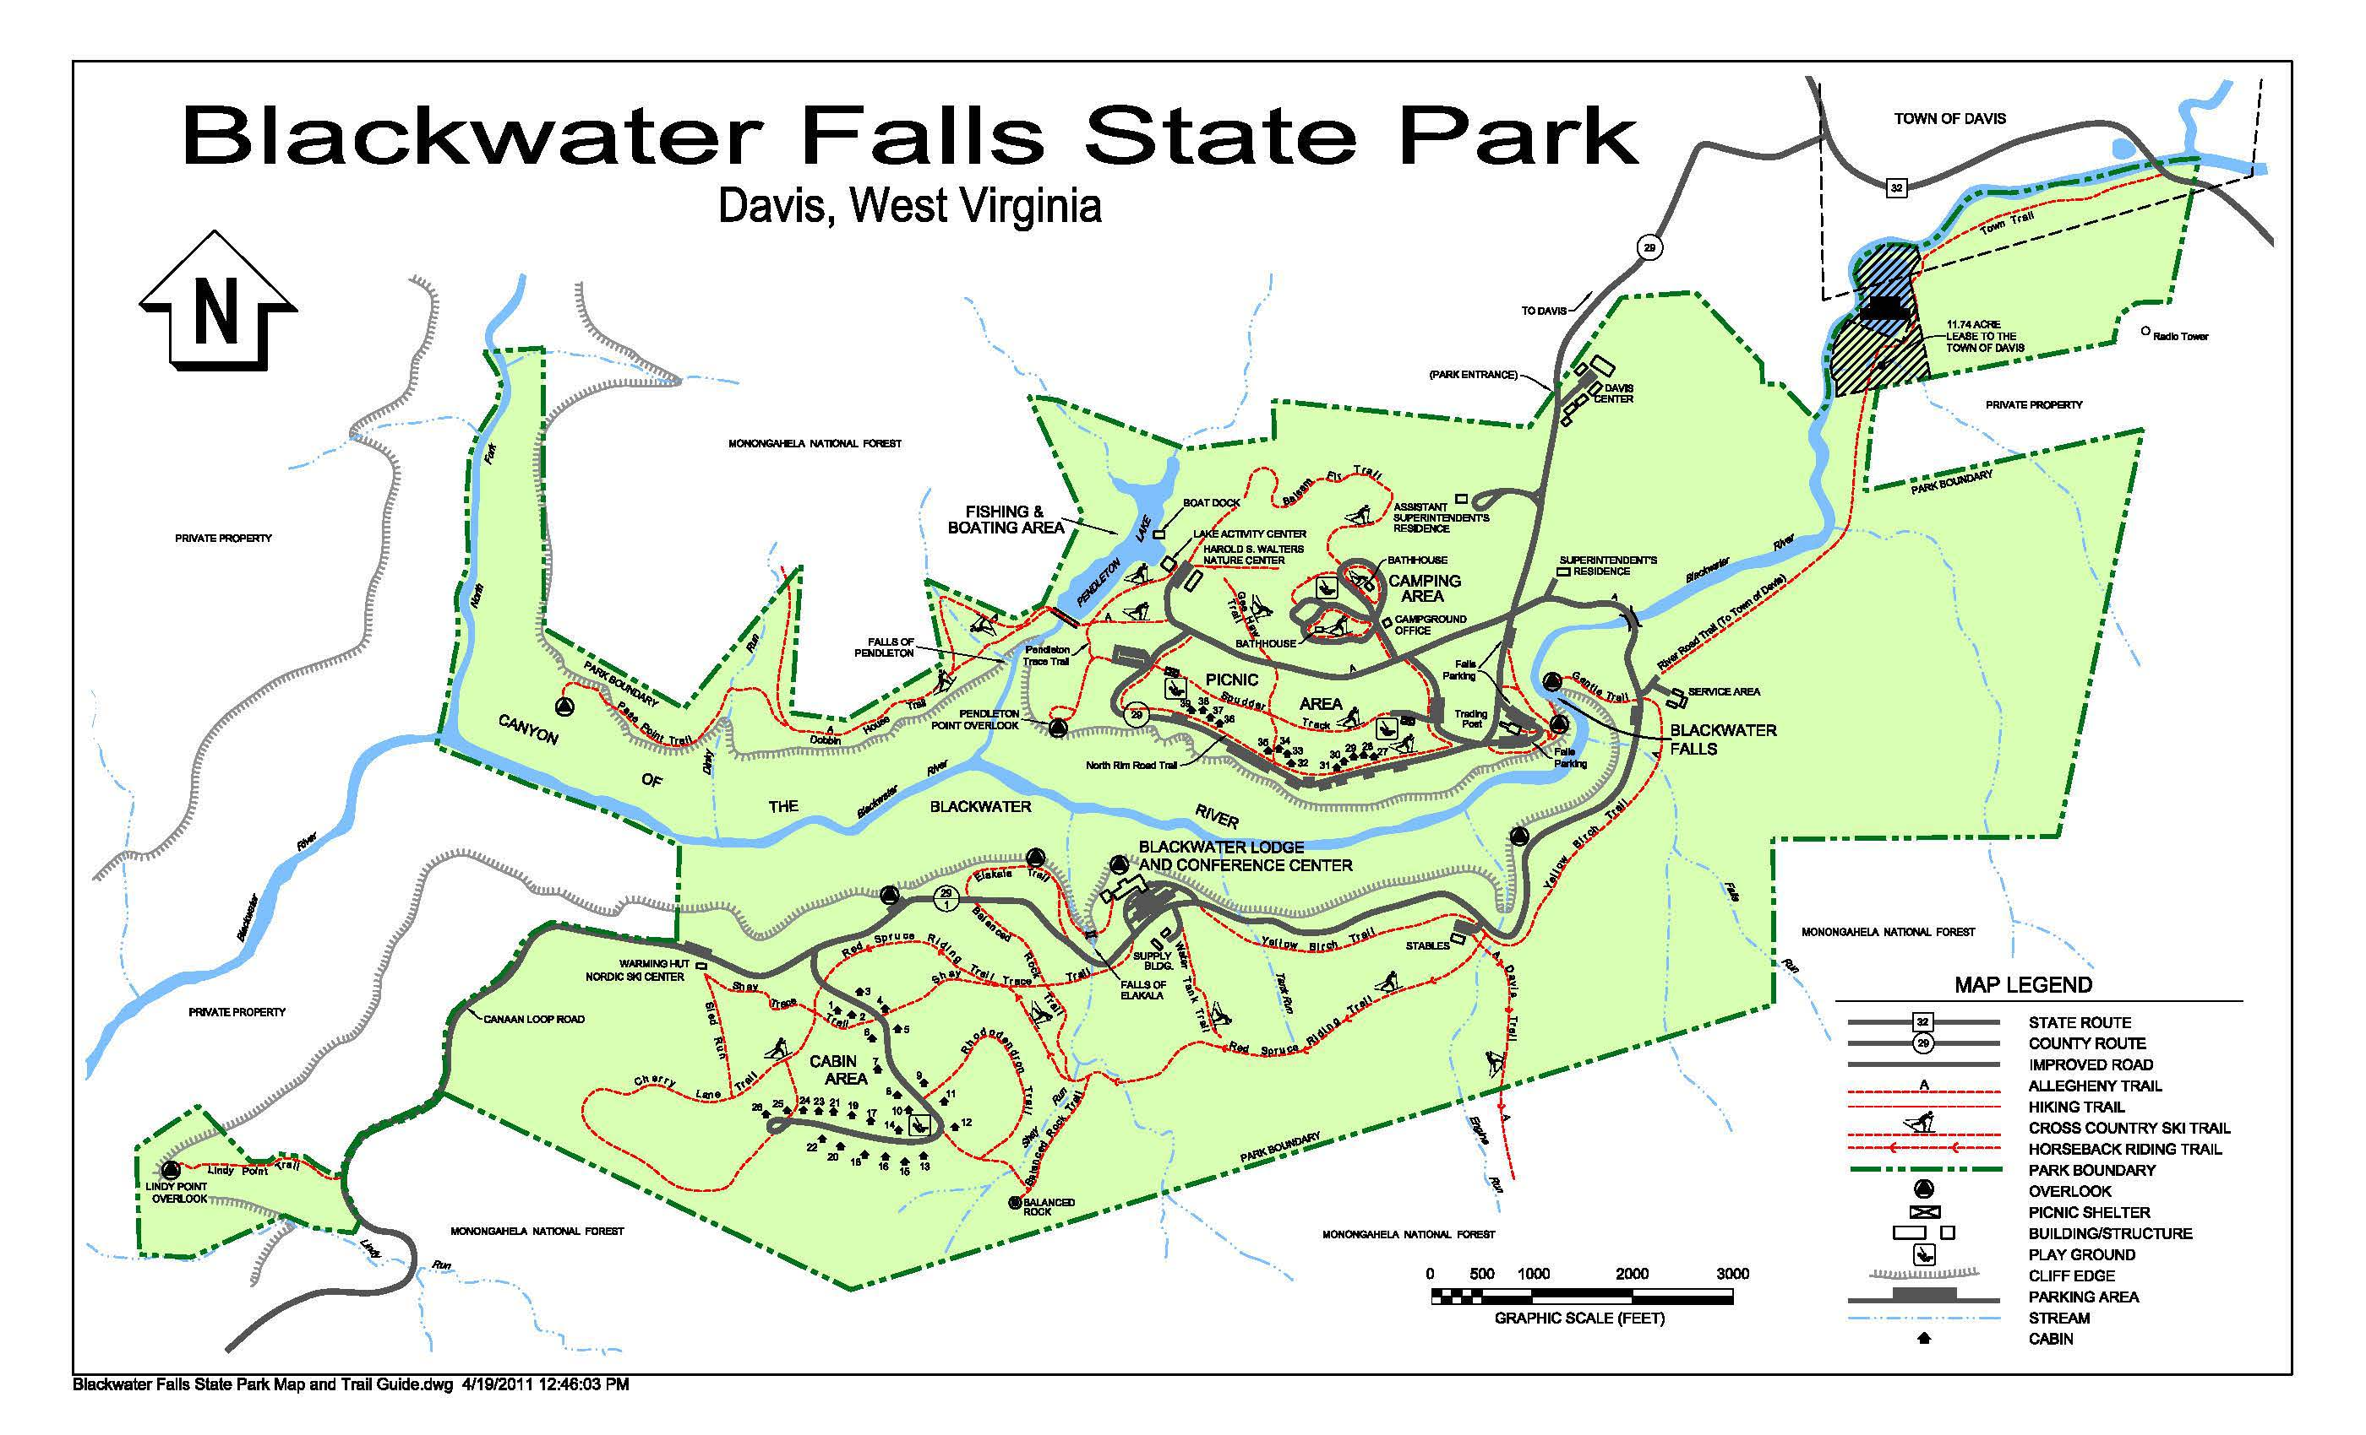
Propane Location Map 100 gallon tanks
500 gallon tanks
1,000 gallon tanks

